**Homework 6**

**Submitted By: Javed Roshan**

**Part 1: GStreamer**

**1. In the lab, you used the Nvidia sink nv3dsink; Nvidia provides another sink, nveglglessink. Convert the following sink to use nveglglessink.**

gst-launch-1.0 v4l2src device=/dev/video0 ! xvimagesink ! nveglglessink

gst-launch-1.0 v4l2src device=/dev/video0 ! video/x-raw, framerate=30/1 ! videoconvert ! video/x-raw, format=BGR ! nveglglessink

**2. What is the difference between a property and a capability? How are they each expressed in a pipeline?**

An Element is a basic building block for a media pipeline. A ‘source element’ as shown below generates data for use by a pipeline.

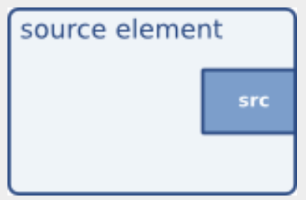

A *Pipeline* can be setup by linking a source element with zero or more *Filter*-like elements and finally a *Sink* element. The data will flow through the elements, and this is the basic concept of media handling in *GStreamer*.

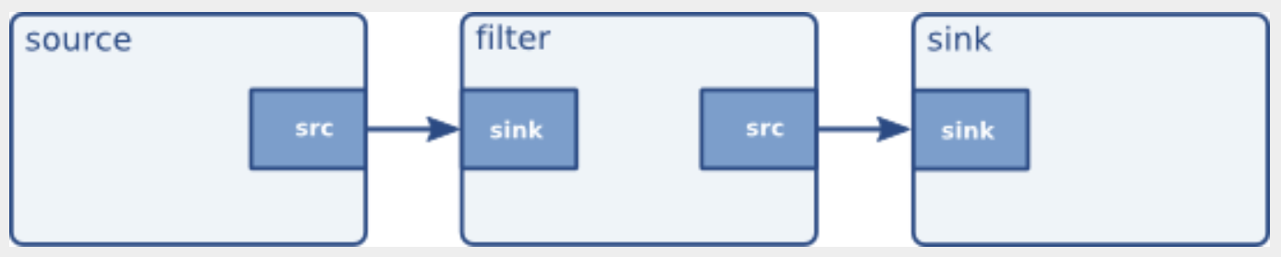

*Pads* are the *Element’s* interface to the outside world. Data streams from one element’s source pad to another element’s sink pad. ***Capability*** is a mechanism that describes the data that can flow through the pad. They are used for compatibility detection, auto-plugging, filtering etc. ***Properties*** are used to describe extra information of *capabilities*. A property consists of a key (a string) and a value.

Following is an example dump of the capabilities of the “***vorbisdec***” element.

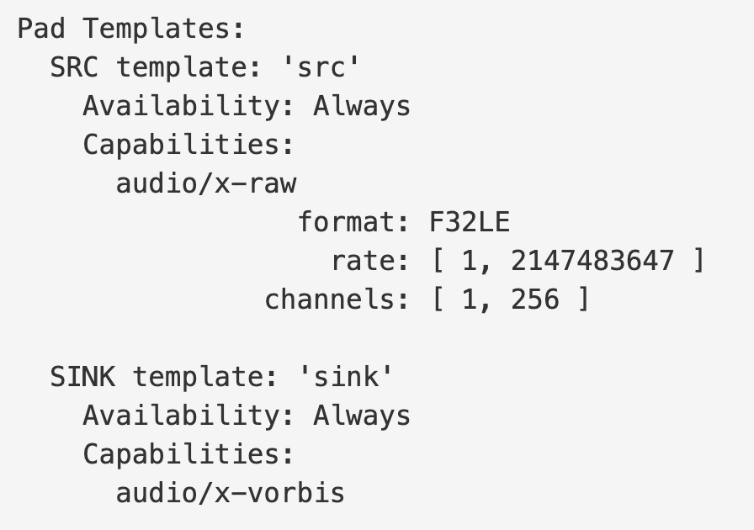

As seen in the dump, there are two pads: a source and a sink pad. Both of these pads are *always* available, and both have capabilities attached to them. The sink pad will accept vorbis-encoded audio data, with the media type “audio/x-vorbis”. The source pad will be used to send raw (decoded) audio samples to the next element, with a raw audio media type (in this case, “audio/x-raw”). The source pad will also contain properties for the audio sample rate (rate: 1, 2147483647) and the number of channels (1, 256).

**3. Explain the following pipeline, that is explain each piece of the pipeline, describing if it is an element (if so, what type), property, or capability. What does this pipeline do?**

gst-launch-1.0 v4l2src device=/dev/video0 ! video/x-raw, framerate=30/1 ! videoconvert ! agingtv scratch-lines=10 ! videoconvert ! xvimagesink sync=false

The above pipeline can be de-constructed as follows:

*v412src device=/dev/video0* shows that the source video data coming from device 0

*video/x-raw* defines the capability of the source that has the *framerate* of 30/1

*videoconvert* is a filter that convert video frames between a great variety of video formats

*agingtv* ages a video stream in real time, changes the colors and adds scratches and dust, the property *scratch-lines=10* defines the number of scratch lines for this video transformation

*xvimagesink* renders video frames to a drawable (XWindow) on a local display using the XVideo extension. *sync* is its property when enabled runs the XWindow in synchronous mode

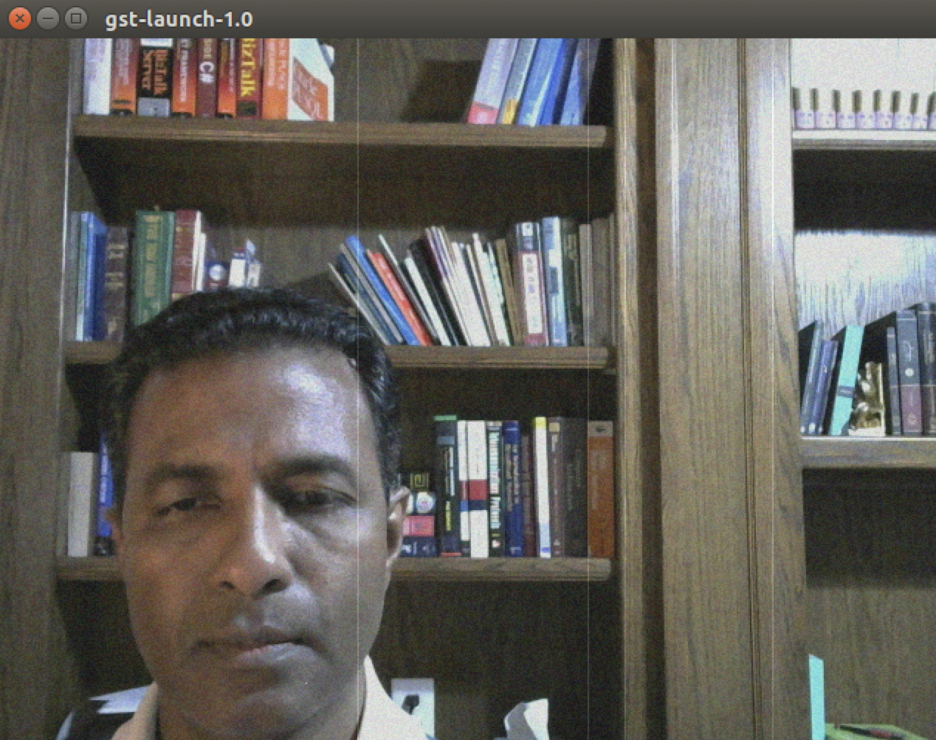

**4. GStreamer pipelines may also be used from Python and OpenCV. For example:**

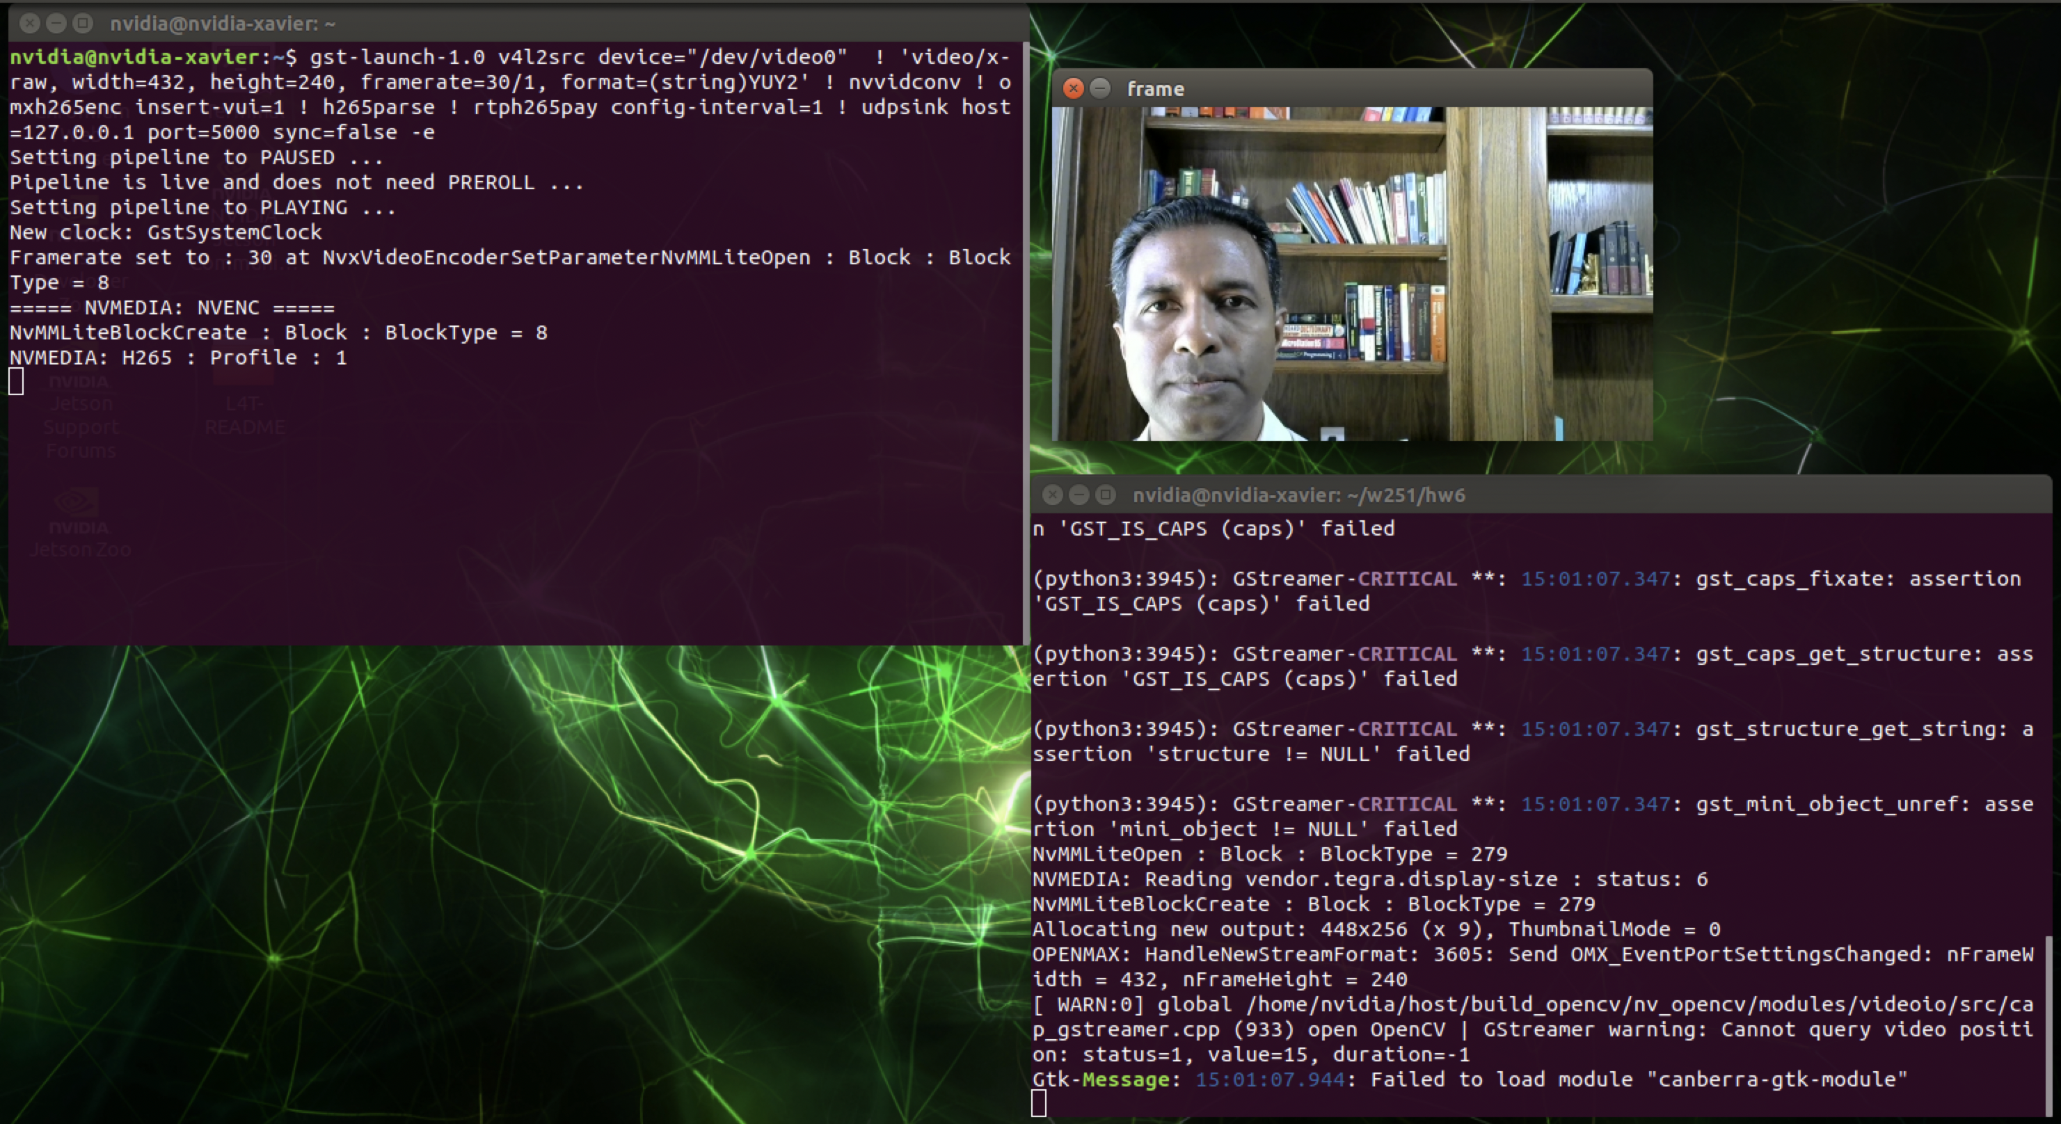

**Publisher:**

gst-launch-1.0 v4l2src device="/dev/video0" ! 'video/x-raw, width=432, height=240, framerate=30/1, format=(string)YUY2' ! nvvidconv ! omxh265enc insert-vui=1 ! h265parse ! rtph265pay config-interval=1 ! udpsink host=127.0.0.1 port=5000 sync=false

**Listener:**

Camera Setting: udpsrc port=5000 ! application/x-rtp, media=video, width=640, height=480, payload=96, clock-rate=90000, encoding-name=H265 ! rtph265depay ! h265parse ! omxh265dec ! videoconvert ! appsink

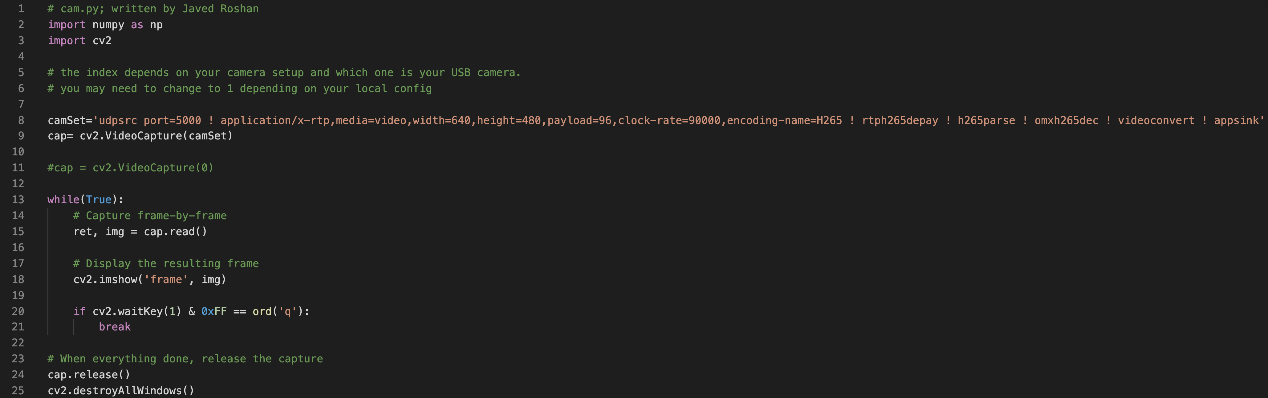

**Part 2: Model optimization & quantization**

The base model was trained on a total of 2500 images downloaded via

python3 open_images_downloader.py --max-images=2500 --class-names "Apple,Orange,Banana,Strawberry,Grape,Pear,Pineapple,Watermelon" --data=data3/fruit

The base model was downloaded from

wget https://nvidia.box.com/shared/static/djf5w54rjvpqocsiztzaandq1m3avr7c.pth -O models/mobilenet-v1-ssd-mp-0_675.pth

Following is the model architecture:

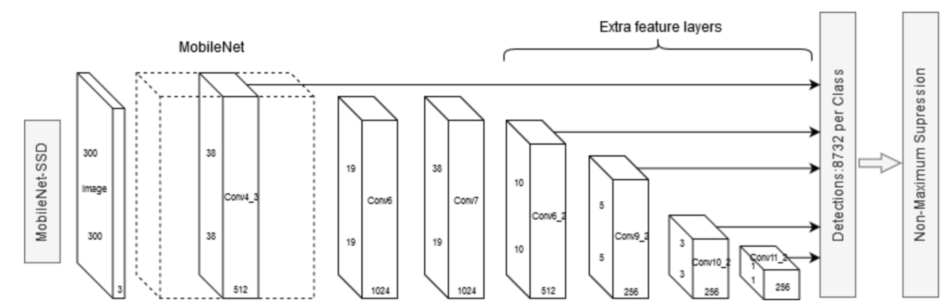

It was run for 30 epochs with batch size as 4

python3 train_ssd.py --data=data3/fruit --model-dir=models/fruit --batch-size=4 --epochs=30

The data format with some examples is as follows:

|  |  |  |  |
| --- | --- | --- | --- |
| ImageID | 0026df6bcaf93ac5 | 0026df6bcaf93ac5 | 003be557ebbb9e8c |
| Source | xclick | Xclick | activemil |
| LabelName | /m/0kpqd | /m/0kpqd | /m/0kpqd |
| Confidence | 1 | 1 | 1 |
| XMin | 0.333125 | 0.488125 | 0.24875 |
| XMax | 0.57625 | 0.9725 | 0.326875 |
| YMin | 0.270833 | 0.360833 | 0.846516 |
| YMax | 0.474167 | 0.999167 | 0.935028 |
| IsOccluded | 1 | 0 | -1 |
| IsTruncated | 0 | 1 | -1 |
| IsGroupOf | 0 | 0 | -1 |
| IsDepiction | 0 | 0 | -1 |
| IsInside | 0 | 0 | -1 |
| id | /m/0kpqd | /m/0kpqd | /m/0kpqd |
| ClassName | Watermelon | Watermelon | Watermelon |

The images are linked with the ImageIds and are split into train, validation, & test directories. “fruit” is the category of the images selected for this training.